CT077-3-2-DSTR DATA STRUCTURES
Lab 1: Getting Started with C++
Part C: Practice Yourself with More Questions
Name: Ian Chin Jun Sheng
Student ID: TP076218
Intake Code: APU2F2602CS (AI)

Question 1
// Lab 1 - Part C - Question 1
// Calendar application

#include <iostream>
#include <iomanip>
#include <string>
using namespace std;

bool isLeapYear(int year)
{
return (year % 4 == 0 && year % 100 != 0) || (year % 400 == 0);
}

int daysInMonth(int month, int year)
{
switch (month)
{
case 1: case 3: case 5: case 7: case 8: case 10: case 12:
return 31;
case 4: case 6: case 9: case 11:
return 30;
case 2:
return isLeapYear(year) ? 29 : 28;
}
return 0;
}

string monthName(int month)
{
switch (month)
{
case 1: return "January";
case 2: return "February";
case 3: return "March";
case 4: return "April";
case 5: return "May";
case 6: return "June";
case 7: return "July";
case 8: return "August";
case 9: return "September";
case 10: return "October";
case 11: return "November";
case 12: return "December";
}
return "Unknown";
}

int startDayOfMonth(int month, int year)
{
int m = month;
int y = year;
if (m < 3)
{
m += 12;
y -= 1;
}
int k = y % 100;
int j = y / 100;
int h = (1 + (13 * (m + 1)) / 5 + k + k / 4 + j / 4 + 5 * j) % 7;
return (h + 6) % 7;
}

void printCalendar(int month, int year)
{
cout << endl;
cout << setw(45) << right << "Calendar Title : "
<< monthName(month) << " - " << year << endl;
cout << "-------------------------------------------------------------------------------" << endl;
cout << setw(11) << "Sunday" << setw(11) << "Monday" << setw(11) << "Tuesday"
<< setw(11) << "Wednesday" << setw(11) << "Thursday" << setw(11) << "Friday"
<< setw(11) << "Saturday" << endl;
cout << "-------------------------------------------------------------------------------" << endl;

int start = startDayOfMonth(month, year);
int total = daysInMonth(month, year);

for (int i = 0; i < start; i++)
cout << setw(11) << " ";

for (int day = 1; day <= total; day++)
{
cout << setw(11) << day;
if ((start + day) % 7 == 0)
cout << endl;
}
if ((start + total) % 7 != 0)
cout << endl;

cout << "-------------------------------------------------------------------------------" << endl;
}

int main()
{
int year, month, choice;

do
{
do
{
cout << "Enter calendar's year: ";
cin >> year;
if (cin.fail() || year < 1)
{
cin.clear();
cin.ignore(1000, '\n');
cout << "Invalid year! Please enter a positive year." << endl;
year = 0;
}
} while (year < 1);

do
{
cout << "Enter calendar's month: ";
cin >> month;
if (cin.fail() || month < 1 || month > 12)
{
cin.clear();
cin.ignore(1000, '\n');
cout << "Invalid month! Please enter 1 to 12." << endl;
month = 0;
}
} while (month < 1 || month > 12);

printCalendar(month, year);

cout << endl << "Do you want to see other month? 1 = Yes, others = No: ";
cin >> choice;
if (cin.fail())
{
cin.clear();
cin.ignore(1000, '\n');
choice = 0;
}
cout << endl;
} while (choice == 1);

cout << "Thank you for using the calendar application." << endl;
return 0;
}

Program output
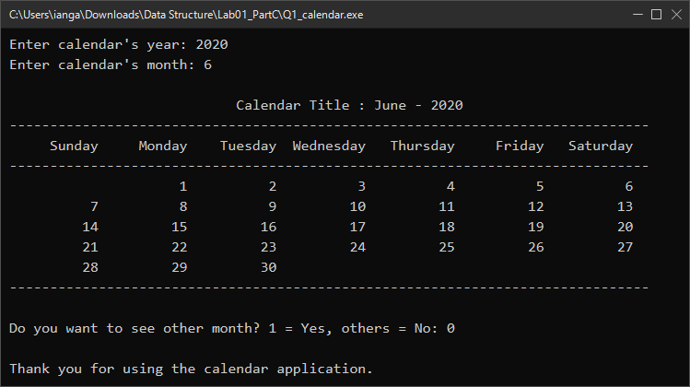

Question 2
// Lab 1 - Part C - Question 2
// Weather forecast tracker for one month (no array allowed)

#include <iostream>
#include <string>
#include <cctype>
using namespace std;

bool isLeapYear(int year)
{
return (year % 4 == 0 && year % 100 != 0) || (year % 400 == 0);
}

int monthNumber(string name)
{
for (unsigned int i = 0; i < name.length(); i++)
name[i] = tolower(name[i]);

if (name == "january") return 1;
if (name == "february") return 2;
if (name == "march") return 3;
if (name == "april") return 4;
if (name == "may") return 5;
if (name == "june") return 6;
if (name == "july") return 7;
if (name == "august") return 8;
if (name == "september") return 9;
if (name == "october") return 10;
if (name == "november") return 11;
if (name == "december") return 12;
return 0;
}

int daysInMonth(int month, int year)
{
switch (month)
{
case 1: case 3: case 5: case 7: case 8: case 10: case 12:
return 31;
case 4: case 6: case 9: case 11:
return 30;
case 2:
return isLeapYear(year) ? 29 : 28;
}
return 0;
}

int main()
{
string monthText;
int year = 0;
int month = 0;

do
{
cout << "Enter Your Month (e.g. August 2019): ";
cin >> monthText >> year;

if (cin.fail())
{
cin.clear();
cin.ignore(1000, '\n');
cout << "Invalid input!" << endl;
month = 0;
continue;
}

month = monthNumber(monthText);
if (month == 0 || year < 1)
cout << "Invalid input!" << endl;

} while (month == 0 || year < 1);

int totalDays = daysInMonth(month, year);
int hot = 0, rainy = 0, cloudy = 0;
char forecast;

for (int day = 1; day <= totalDays; day++)
{
cout << "Day " << day
<< " : Enter \"H\" for Hot, \"R\" for Rainy, \"C\" for Cloudy, (\"E\" to end): ";
cin >> forecast;
forecast = toupper(forecast);

if (forecast == 'E')
break;
else if (forecast == 'H')
hot++;
else if (forecast == 'R')
rainy++;
else if (forecast == 'C')
cloudy++;
else
{
cout << "Invalid input! Please enter H, R, C or E." << endl;
day--;
}
}

cout << "Number of hot days this month: " << hot << endl;
cout << "Number of rainy days this month: " << rainy << endl;
cout << "Number of cloud days this month: " << cloudy << endl;

return 0;
}

Program output
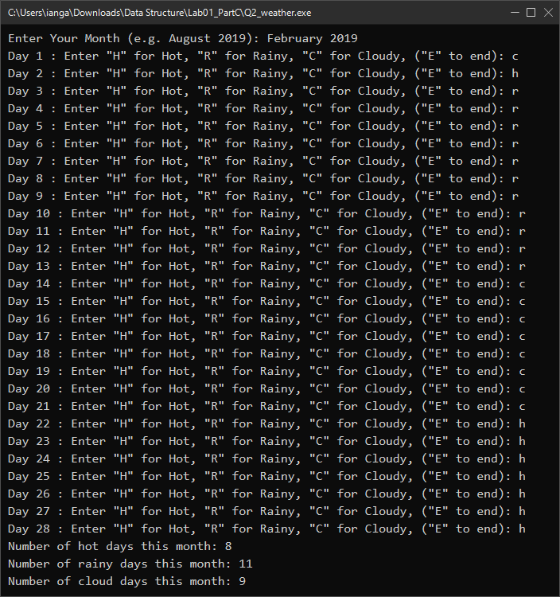
Question 3
// Lab 1 - Part C - Question 3
// Financials: currency exchange (USD <-> RMB)

#include <iostream>
#include <iomanip>
using namespace std;

int main()
{
double rate, amount, result;
int option;

cout << "Enter the exchange rate from dollars to RMB: ";
cin >> rate;

if (cin.fail() || rate <= 0)
{
cout << "Invalid exchange rate!" << endl;
return 1;
}

cout << "Enter 0 to convert dollars to RMB and 1 vice versa: ";
cin >> option;

if (cin.fail())
{
cout << "Invalid input!" << endl;
return 1;
}

cout << fixed << setprecision(1);

if (option == 0)
{
cout << "Enter the dollar amount: ";
cin >> amount;
result = amount * rate;
cout << "$" << amount << " is " << result << " yuan" << endl;
}
else if (option == 1)
{
cout << "Enter the RMB amount: ";
cin >> amount;
result = amount / rate;
cout << amount << " yuan is $" << setprecision(2) << result << endl;
}
else
{
cout << "Incorrect input" << endl;
}

return 0;
}
Program output
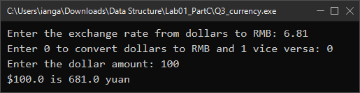
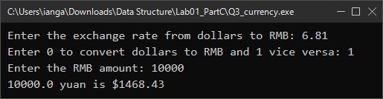

Question 4
// Lab 1 - Part C - Question 4
// Print a diamond pattern using loops

#include <iostream>
using namespace std;

int main()
{
int rows;

do
{
cout << "Enter number of rows (for diamond (triangle) dimension) : ";
cin >> rows;
if (cin.fail() || rows < 1)
{
cin.clear();
cin.ignore(1000, '\n');
cout << "Invalid input! Please enter a positive number." << endl;
rows = 0;
}
} while (rows < 1);

for (int i = 1; i <= rows; i++)
{
for (int space = 1; space <= rows - i; space++)
cout << " ";
for (int star = 1; star <= 2 * i - 1; star++)
cout << "*";
cout << endl;
}

for (int i = rows - 1; i >= 1; i--)
{
for (int space = 1; space <= rows - i; space++)
cout << " ";
for (int star = 1; star <= 2 * i - 1; star++)
cout << "*";
cout << endl;
}

return 0;
}
Program output
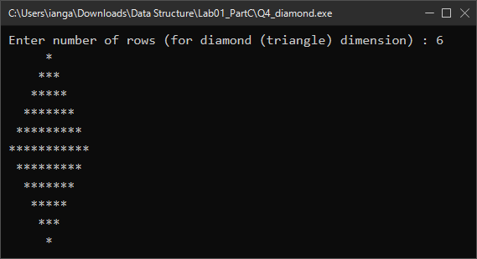
Question 5
// Lab 1 - Part C - Question 5
// Print the even numbers between 1 and 50, five numbers per line

#include <iostream>
#include <iomanip>
using namespace std;

int main()
{
int count = 0;

for (int i = 1; i <= 50; i++)
{
if (i % 2 == 0)
{
cout << setw(4) << i;
count++;
if (count % 5 == 0)
cout << endl;
}
}

return 0;
}
Program output
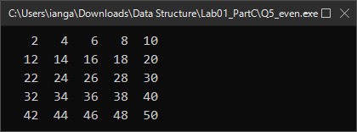
Question 6
// Lab 1 - Part C - Question 6
// Determine a student's grade from quiz, mid-term and final scores

#include <iostream>
using namespace std;

int main()
{
double quiz, midTerm, final, average;
char grade;

cout << "Enter 3 scores (quiz, mid-term, and final) vales separated by space:";
cin >> quiz >> midTerm >> final;

if (cin.fail())
{
cout << "Invalid input!" << endl;
return 1;
}

if (quiz < 0 || quiz > 100 || midTerm < 0 || midTerm > 100 || final < 0 || final > 100)
{
cout << "Invalid score! Each score must be between 0 and 100." << endl;
return 1;
}

average = (quiz + midTerm + final) / 3;

if (average >= 90)
grade = 'A';
else if (average >= 70)
grade = 'B';
else if (average >= 50)
grade = 'C';
else
grade = 'F';

cout << "Grade " << grade << endl;

return 0;
}
Program output
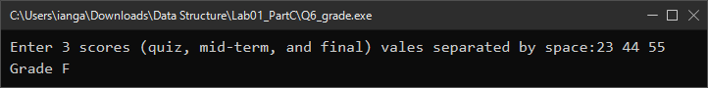

Question 7
// Lab 1 - Part C - Question 7
// Compare the areas of two rectangles

#include <iostream>
using namespace std;

int main()
{
double widthA, heightA, widthB, heightB;
double areaA, areaB;

cout << "Rectangle A:" << endl;
cout << "Width = ";
cin >> widthA;
cout << "Height = ";
cin >> heightA;

cout << endl << "Rectangle B:" << endl;
cout << "Width = ";
cin >> widthB;
cout << "Height = ";
cin >> heightB;

if (cin.fail() || widthA <= 0 || heightA <= 0 || widthB <= 0 || heightB <= 0)
{
cout << "Invalid input! Width and height must be positive numbers." << endl;
return 1;
}

areaA = widthA * heightA;
areaB = widthB * heightB;

cout << endl;
if (areaA > areaB)
cout << "Area in rectangle A is bigger rectangle B." << endl;
else if (areaB > areaA)
cout << "Area in rectangle B is bigger rectangle A." << endl;
else
cout << "Area in rectangle A and rectangle B are the same." << endl;

return 0;
}
Program output
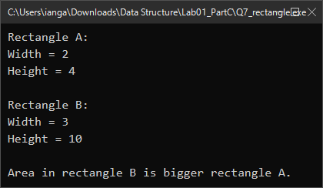

Question 8
// Lab 1 - Part C - Question 8
// Total cost of a meal inclusive of 6% GST and tipping

#include <iostream>
#include <iomanip>
using namespace std;

int main()
{
const double GST_RATE = 0.06;
double mealCost, tipPercent;
double gstAmount, costAfterGst, tipAmount, totalCost;

cout << "Enter the cost of the meal (before GST and tipping): RM ";
cin >> mealCost;

if (cin.fail() || mealCost < 0)
{
cout << "Invalid meal cost!" << endl;
return 1;
}

cout << "Enter the tip amount (in percentage): ";
cin >> tipPercent;

if (cin.fail() || tipPercent < 0)
{
cout << "Invalid tip percentage!" << endl;
return 1;
}

gstAmount = mealCost * GST_RATE;
costAfterGst = mealCost + gstAmount;
tipAmount = costAfterGst * (tipPercent / 100);
totalCost = costAfterGst + tipAmount;

cout << fixed << setprecision(2);
cout << endl;
cout << "The total cost of the meal BEFORE GST and tipping : RM " << mealCost << endl;
cout << "The total cost of the meal AFTER GST : RM " << costAfterGst << endl;
cout << "The total cost of the meal AFTER GST and tipping : RM " << totalCost << endl;

return 0;
}
Program output
